**Solution:**

**Part 1:**

**Points to be remembered:**

**Use the provided script in the compiler.**

·         The script needs to be executed in the folder with SQL server.

·         At first, create the database in the computer system that are used.

·         Execute the provided SQL commands.

·         The successful execution of the provided SQL commands can be given in the screenshot.

·         In the execution, each table will be created in a particular order.

·         Refer the screenshot for better understanding of the execution of the SQL commands.

**The tables are created in the below manner:**

**1.** genre_codes

***Execution of the SQL CODE:***

/* genre_codes */

CREATE TABLE genre_codes(

        genre_code int IDENTITY(1,1) NOT NULL,

        genre_code_description varchar(32) NOT NULL);

**The successful completion of the SQL commands will be done:**

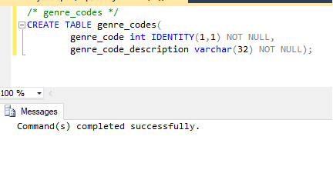

**The given screenshot shows that the table is created in the database db:**

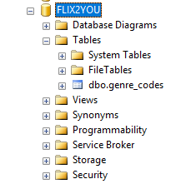

**2.** format_types

***Execution of the SQL CODE:***

/* format_types */

CREATE TABLE format_types(

format_type_code int IDENTITY(1,1) NOT NULL,

format_type_description varchar(32) NOT NULL);

**The successful completion of the SQL commands will be done:**

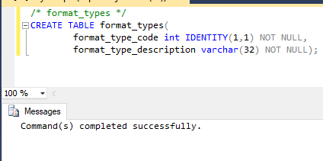

**The given screenshot shows that the table is created in the database db:**

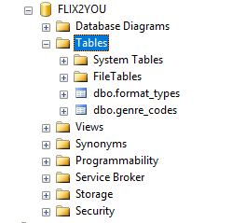

**3.** video_stores

***Execution of the SQL CODE:***

/* video_stores */

CREATE TABLE video_stores(

store_id int IDENTITY(1,1) NOT NULL,

store_name varchar(32) NOT NULL,

store_address varchar(128) NOT NULL,

store_city varchar(32) NOT NULL,

store_state varchar(2) NOT NULL,

store_zip varchar(12) NOT NULL,

store_email varchar(128) NOT NULL,

other_store_details varchar(512) NOT NULL);

**The successful completion of the SQL commands will be done:**

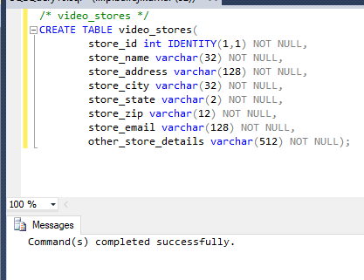

**The given screenshot shows that the table is created in the database db:**

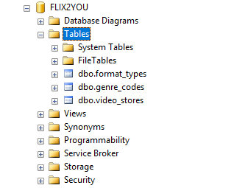

**4.** condition_codes

***Execution of the SQL CODE:***

/* condition_code */

CREATE TABLE condition_codes(

condition_code int IDENTITY(1,1) NOT NULL,

condition_code_description varchar(32) NOT NULL);

**The successful completion of the SQL commands will be done:**

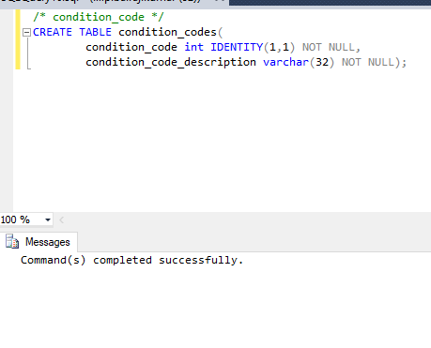

**The given screenshot shows that the table is created in the database db:**

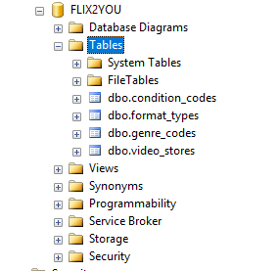

**5.** actors

***Execution of the SQL CODE:***

/* actors */

CREATE TABLE actors(

actor_id int IDENTITY(1,1) NOT NULL,

actor_gender char(1) NOT NULL,

actor_first_name varchar(32) NOT NULL,

actor_last_name varchar(32) NOT NULL,

other_actor_details varchar(512) NOT NULL);

**The successful completion of the SQL commands will be done:**

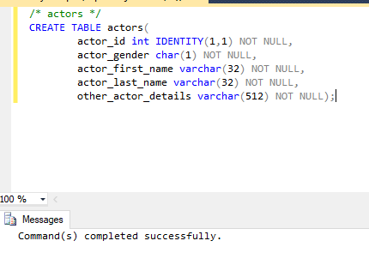

**The given screenshot shows that the table is created in the database db:**

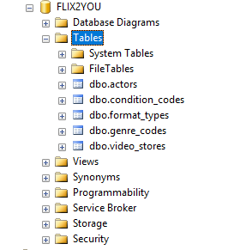

**6.** movies

***Execution of the SQL CODE:***

/* movies */

CREATE TABLE movies(

movie_id int IDENTITY(1,1) NOT NULL,

condition_code int NOT NULL,

format_type_code int NOT NULL,

genre_type_code int NOT NULL,

store_id int NOT NULL,

release_year int NOT NULL,

movie_title varchar(128) NOT NULL,

movie_description varchar(1024) NOT NULL,

number_in_stock int NOT NULL,

rental_or_sale_or_both tinyint NOT NULL,

rental_daily_rate money NOT NULL,

sales_price money NOT NULL);

**The successful completion of the SQL commands will be done:**

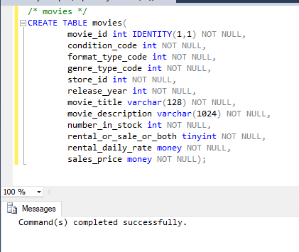

**The given screenshot shows that the table is created in the database db:**

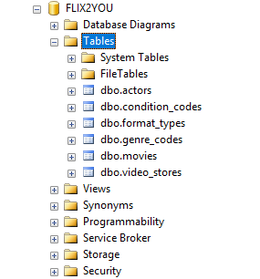

**7.** movie_cast

***Execution of the SQL CODE:***

/* movie_cast */

CREATE TABLE movie_cast(

movie_id int NOT NULL,

actor_id int NOT NULL);

**The successful completion of the SQL commands will be done:**

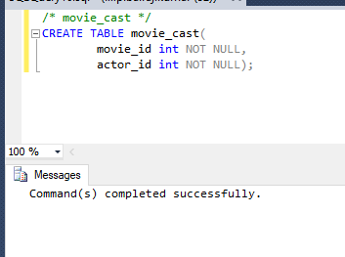

**The given screenshot shows that the table is created in the database db:**

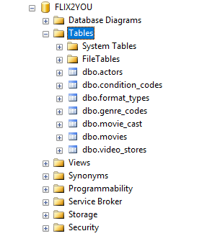

**8.** Alter script of tables to add the primary key constraints in all tables

***Execution of the SQL CODE:***

/* create primary keys with ALTER TABLE statement */

ALTER TABLE genre_codes ADD CONSTRAINT pk_genre_codes PRIMARY KEY (genre_code);

ALTER TABLE format_types ADD CONSTRAINT pk_format_types PRIMARY KEY (format_type_code);

ALTER TABLE video_stores ADD CONSTRAINT pk_video_stores PRIMARY KEY (store_id);

ALTER TABLE condition_codes ADD CONSTRAINT pk_condition_codes PRIMARY KEY (condition_code);

ALTER TABLE actors ADD CONSTRAINT pk_actors PRIMARY KEY (actor_id);

ALTER TABLE movies ADD CONSTRAINT pk_movies PRIMARY KEY (movie_id);

ALTER TABLE movie_cast ADD CONSTRAINT pk_movie_cast PRIMARY KEY (movie_id, actor_id);

/* end of primary key creation */

**The successful completion of the SQL commands will be done:**

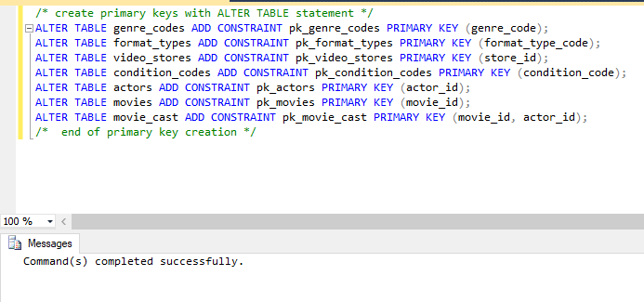

**The given screenshot shows that the resulted table is created in the database db:**

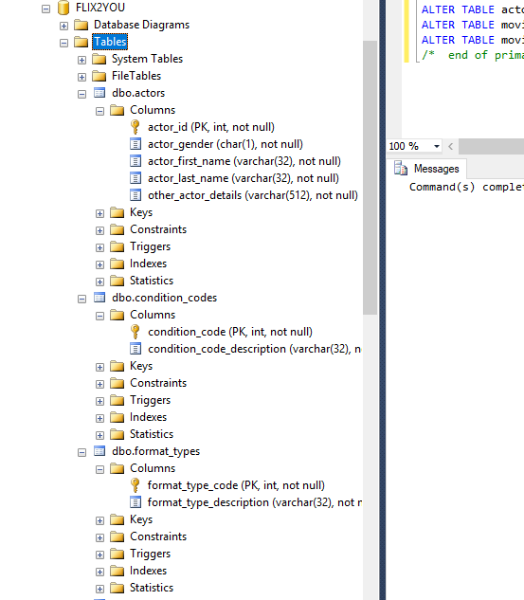

**9.** Alter script of tables to add the foreign key constraints in movie_cast and movies table

***Execution of the SQL CODE:***

/* create foreign keys */

ALTER TABLE movie_cast ADD CONSTRAINT fk_Movie_cast_actors FOREIGN KEY(actor_id)

REFERENCES actors (actor_id);

ALTER TABLE movie_cast ADD CONSTRAINT fk_movie_cast_movies FOREIGN KEY(movie_id)

REFERENCES movies (movie_id);

ALTER TABLE movies ADD CONSTRAINT fk_movies_condition_codes FOREIGN KEY(condition_code)

REFERENCES condition_codes (condition_code);

ALTER TABLE movies ADD CONSTRAINT fk_movies_format_types FOREIGN KEY(format_type_code)

REFERENCES format_types (format_type_code);

ALTER TABLE movies ADD CONSTRAINT fk_movies_genre_codes FOREIGN KEY(genre_type_code)

REFERENCES genre_codes (genre_code);

ALTER TABLE movies ADD CONSTRAINT fk_movies_video_Stores FOREIGN KEY(store_id)

REFERENCES video_Stores (store_id);

**The successful completion of the SQL commands will be done:**

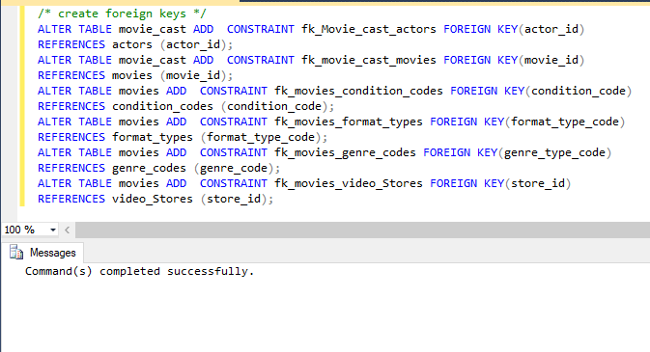

**The given screenshot shows that the resulted table is created in the database db:**

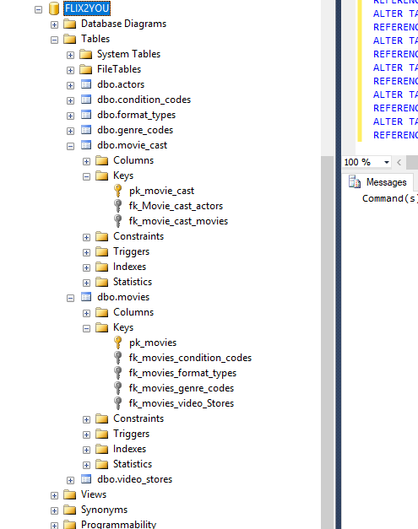

**10.** **SQL Data Dictionary:**

**The successful completion of the SQL data dictionary will be done.**

The given screenshot shows that the resulted script is created in the database db which returns the data detailed description of columns:

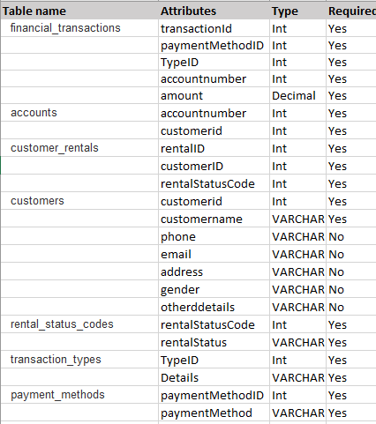

**Part 2:**

·         The data is inserted into the 2nd set of 7 tables.

·         The tables are created, and the SQL code will be written to create the 2nd set of 7 tables.

·         Refer the question to know the values that need to be inserted.

·         The successful execution of the provided SQL commands can be given.

***Execution of the SQL CODE:***

CREATE TABLE Customers(  
    LastName VARCHAR(50) NOT NULL PRIMARY KEY,  
    FirstName VARCHAR(50),  
    Addr_Street VARCHAR(50),  
    Addr_City VARCHAR(50),  
    Addr_State CHAR(2),  
    Addr_Zip CHAR(5),  
    Email VARCHAR(50)  
);

CREATE TABLE CustomerRentals(  
    Customer VARCHAR(50),  
    Movie VARCHAR(50),  
    Status VARCHAR(10),  
    DateOut DATE,  
    DateReturned DATE,  
    AmountDue REAL(5,2),  
    FOREIGN KEY(Customer) REFERENCES Customers(LastName)  
);

CREATE TABLE FinancialTransactions(  
    Customer VARCHAR(50),  
    Movie VARCHAR(50),  
    Type VARCHAR(10),  
    PayMethod VARCHAR(10),  
    Amount REAL(5,2),  
    `Date` DATE  
    FOREIGN KEY(Customer) REFERENCES Customer(LastName)  
);

INSERT INTO Customers VALUES('Smith', 'Harry', '1206 O Neill', 'Dunmore', 'PA', 18512, 'Fast_harry AT hotmail.com');  
INSERT INTO Customers VALUES('Jones', 'Sally', '436 7th Ave', 'Pittsburgh', 'PA', 15219, 'jones_sally AT mail.com');  
INSERT INTO Customers VALUES('Ryder', 'Amy', '4172 William Penn Highway', 'Monroeville', 'PA', 15146, 'crazy_amy ATyahoo.com');  
INSERT INTO Customers VALUES('Walker', 'Skip', '503 Linden St.', 'Scranthon', 'PA', 18503);  
INSERT INTO Customers VALUES('Murphy', 'Nick','205 S Main St', 'Zelienople', 'PA'. 16063);

INSERT INTO CustomerRentals VALUES('Murphy', 'Spider-Man', 'Active', '2017/8/3', NULL, 5.50);  
INSERT INTO CustomerRentals VALUES('Jones', 'Superbad', 'Reserved', NULL, NULL, NULL);  
INSERT INTO CustomerRentals VALUES('Ryder', 'Gone w/ Wind', 'Overdue', '2017/6/2', NULL, 18.87);  
INSERT INTO CustomerRentals VALUES('Walker', 'Fahr 9/11', 'Returned', '2017/1/5', '2017/5/20', 4.61);  
INSERT INTO CustomerRentals VALUES('Smith', 'Good Will', 'Active', '2012/10/7', NULL, 4.56);

INSERT INTO FinancialTransactions VALUES('Smith', 'Good Will', 'Payment', 'Cash', 4.56, '2017/7/10');  
INSERT INTO FinancialTransactions VALUES('Jones', 'Superbad', 'Deposit', 'Credit card', 10.00, '2017/5/1');  
INSERT INTO FinancialTransactions VALUES('Ryder', 'Gone w/ W', 'Payment', 'Paypal', 18.87, '2017/6/2');  
INSERT INTO FinancialTransactions VALUES('Walker', 'Fahr 9/11', 'Payment', 'Check', 4.61, '2017/5/1');  
INSERT INTO FinancialTransactions VALUES('Walker', 'Fahr 9/11', 'Refund', 'Refund', 'Check', 1.00, '2017/5/30');

**Part 3:**

·         The data is updated into the tables to correct the errors.

·         Whenever the field will be identified as a primary key, that needs to be updated and modified.

·         Refer the question to know the updated values that need to be inserted.

·         The successful execution of the provided SQL commands can be given.

***Execution of the SQL CODE:***

UPDATE Customers SET Addr_Zip = 18502 WHERE LastName = 'Walker';  
UPDATE FinancialTransactions SET Movie = 'Fahr 9/11' WHERE Customer = 'Smith';